TAMPULMA
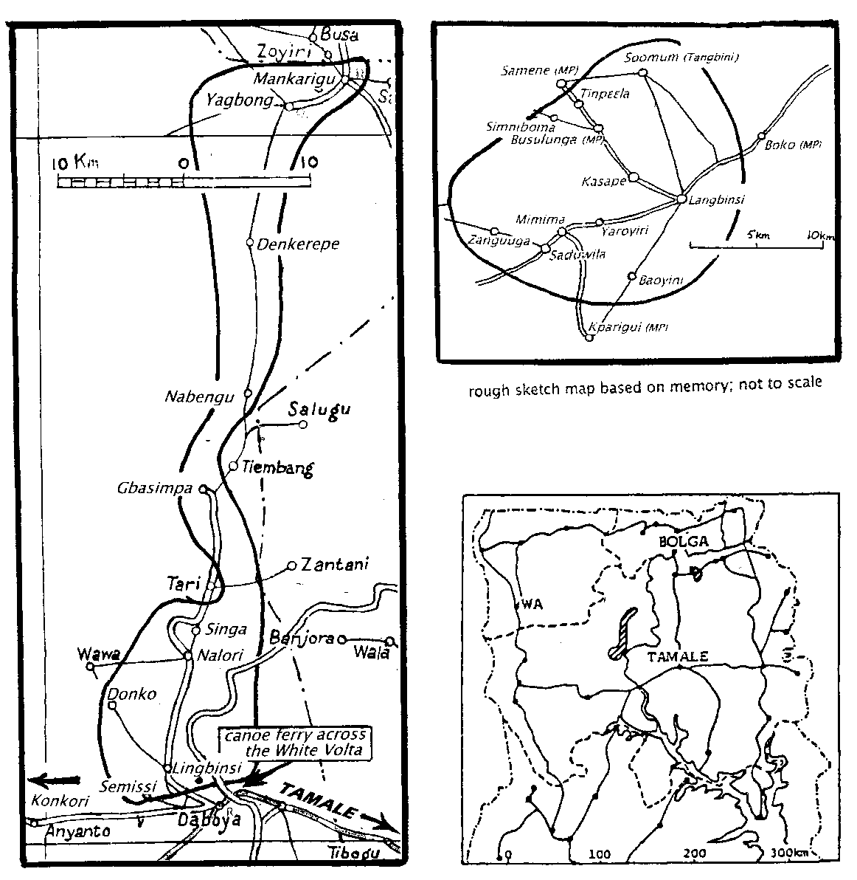
location Two settlements, both in Northern Region: in East Mamprusi District, main town Langbinsi (near Gambaga), a cluster of villages on either side of the Walewale-Gambaga road; and in West Gonja District, main town Lingbinsi (near Daboya), a strip 60 km from north to south, along the eastern border of the Mole Game Reserve,; The two settlements are about 70 km apart. To remember which is which, note that the “a” town is to NE, and the “i” town is to the SW.
There is no direct route between Langbinsi and Lingbinsi. One must travel via Tamale and Walewale.

TAMPULMA POPULATION (2000 Census gives no separate figures for Tampulma; the Census figures below are those for “Other Grusi (Lela, Templensi)”
Table 1 TAMPULMA COMPARED BY YEAR
 | 1960 Census | 1984 estimate | 2000 Census (inc “Lela”) | Joshua Project 2006 estimate
3 N Regions | not  listed | 10,000 | 23,107
 | not  listed | (not listed in Census)
Other 7 Regions | not  listed | 10,000 | 20,099
GHANA Total | not  listed | 20,000 | 43,205 | 51,090
un
Table 2 TAMPULMA COMPARED BY REGION 2000 Census
Northern
Upper East | Upper West | Northern | North Total
1,317 | 2,120 | 19,670 | 23,107
Southern
Western | Central | Greater Accra | Volta
1,649 | 787 | 4,387 | 331
Eastern | Ashanti | Brong Ahafo | South Total
2,762 | 7,060 | 3,122 | 20,099
Ghana Total |  |  | 43,205
MIGRATION
There are small Tampulma settlements in southern Ghana -- the figures of regional population above probably include migrant farm labourers, for many Tampulma go south in November and December to work on cocoa farms and return before their own farming season begins in May or June. There are migrant farmers in Brong Ahafo (Afram plains, Ejura, Techiman), and other Tampulma communities in Accra and Kumasi.
People migrate in search of prosperity; for fear of witchcraft and spiritual attacks; for better medical facilities especially in child-birth. 15% of Tampulma are estimated to have migrated to the southern regions.
[is there a Tampulma association of any kind linking Tampulimsa in different places; if so, who are the contact people?]
LANGUAGE AND DIALECTS
Tampulim is a Gur language of the Grusi (west) sub-group, most closely related to Isaaling, Chakali, Vagla, and Dɛg.
Language use In the Langbinsi settlement, Mampruli is the trade language, and it is taught in school and used in church. Baptist churches in the Langbinsi area use Tampulim. (ICG)
Dialects are 1) Langbinsi-Gambaga; 2) Lingbinsi-Daboya; 3) Yagbong Mankariga; 4) Kinkori (spoken in a village 25 km west of the southern settlement). All are mutually intelligible, with minor phonological and vocabulary differences.
There are slight differences between the dialect spoken at the north and south ends of the Daboya settlement, perhaps because the people of Mankariga and Yabum remained in the south-west when the others moved north to serve with the Mamprusi. (SA)
LITERACY AND BIBLE TRANSLATION
by GILLBT | NT & literacy started | NT first & second printings | students enrolled | whole Bible printed | Jesus film shown | NT on audio tape | no of churches & classes
1966/67 | 1972 | 1978 & 92 | 1984 - 600 2010 - 1,272 | 1999 | 2000 | 2008 | 64 churches  88 classes
The church literacy programme is funded by Wycliffe Canada, and involves Presbyterian, Baptist, SDA, Pentecost, and Catholic churches.
Prior to 1985 GILLBT’s literacy work led to the opening of eight new Baptist churches: all are still going strong, except two which need stronger leadership; see table below.
In the NE Sector, Langbinsi, Gladys, wife of a Baptist worker, is coordinator for literacy.
In the SW Sector, Lingbinsi, John Tikaa runs the literacy work, and Samuel Asare is SIU Co-ordinator.
Many Tampulma pastors have been trained to lead local churches using Scriptures in their mother tongue. [which churches? – when did this start? is it a continuing programme? are pastors still being trained today? both Langbinsi and Lingbinsi?] (SA)
ORIGINS AND HISTORY
The Gonja have been dominant since the 1600s, from Bole in the west, and Daboya in the north, to Salaga in the east. In the early or mid-1800s [who has given this date?] some 800 Tampulma people crossed the Black Volta from what is now Burkina Faso and settled at a place in the north-west then called Kadichaara, now called Kpaya, which is some 30-40 miles from Daboya [I can’t find Kpaya on GS 1:500,000 map]. Their leader was called Kadichaara tiina. (SA)
It appears that for a time the Tampulma shared a common history with Sisaala, Vagla, and Dega. These four peoples certainly have a tradition that they were all originally one but quarrelled over the sacrifice of a dog. When the remains were being divided among those present the Sisaala claimed the head; the others would not agree and there was a fight. As a result they split up and they all migrated, ultimate reaching their present locations. (ICG)
Today the Tampulma themselves are divided into two settlements, located as described above (“Location”). Two theories are given to explain the division:
First theory The north-east (East Mamprusi District) settlement is the original one, and Tampulma were already living near Gambaga when the Mamprusi chief engaged them as mercenaries to support him, either in a bid for the paramountcy or in a war against the Anufo. According to this account the Lingbinsi-Daboya settlement was formed later by migration, led by Kankoor Ameyaw and Kankoor Manga I. (ICG)
During the farming season they stopped to farm at Walewale, then helped the Mamprusi chief to fight the Kusasi and brought him to Nalerigu where he asked them to stay. The Mamprusi chief could not fulfil his promise to pay them and instead gave them the Tampulma chiefs the mandate to rule their own people. (SA) [please give source for this tradition]
Second theory The south-west (Lingbinsi-Daboya,West Gonja District) settlement was the first one, and the north-eastern settlement came about when some Tampulma from the Daboya settlement moved to help the Mamprusi chief in the tribal war against the Anufo. After the fighting the chief asked them not to go back, but to stay and protect him. He invited them to settle on land between Gambaga and Walewale, mentioning a payment of hundreds of every kind of living creature including human beings. That agreement has never been fulfilled. (SA)
These Tampulma people were dedicated to war. They did not pay tribute to Mamprusi chiefs, nor did they think of owning land. Their chiefs are Tampulma - no Tampulma village in East Mamprusi District has a Mamprusi chief. [please quote the source of this tradition] (SA)
The two communities are related by family, culture, and traditional practices; they attend each other’s funerals, marriages, enstoolments, and other gatherings.
AUTHORITY
[do the Tampulma communities have effective representation at the East Mamprusi and West Gonja Assemblies in Gambaga and Damongo respectively? please let me have the Tampulma assemblymen’s names and contact details so that I can send them copies of this chapter]
There are three main Tampulma stools: Daboya, outside Tampulim territory, is the seat of the paramount, whose title is Tampunaa; Langbinsi and Lingbinsi are separate stools. During the annual Fire Festival all citizens aim to come together to think about the welfare of the Tampulma nation, and the three chiefs collaborate.
North-east (East Mamprusi District) Up to 1957 the chief of Langbinsi appears to have been a Tampulma appointed as Kambonakpema (head of the warriors); but in that year this chief had a conflict with a neighbouring Mamprusi chief and the Native Authority Court presided over by the Mamprusi paramount chief gave judgment against him. He therefore led a group of Tampulma from Langbinsi and other villages back to the Daboya settlement, while others chose to remain.
Some say that those Tampulma in the north-east have Mamprusi chiefs even where the Tampulma are in a majority.
South-west (West Gonja District) villages have a Kankoora (captain chief) in Lingbinsi who is a Tampulma but is subject to the Gonja chief of Daboya and through him to the Gonja paramount chief in Damongo. (ICG)
Others maintain that the Tampulma owe no such allegiance. They are independent of any other people; they make their own decisions and do not pay tribute to any other chief.
INHERITANCE
From a deceased man the brother? may inherit house, cattle, farm, and wife, together with offices such as chieftaincy, priesthood, and soothsaying. The wife and children may inherit a house ?? [is this seen as patrilineal inheritance?]
Marriage of widows Formerly the one who performed a man’s funeral had the right to marry his widow, but now she may marry anyone of her choice. If a woman chooses not to marry again she inherits a place to stay in the deceased husband’s compound.
THE COMPOUND, FARMING &c
Compounds A compound is occupied by an extended family under its elder. Occasionally the young people live in a smaller compound nearby. A typical compound has about 20 huts, most of them round and thatched. Compounds are about 200 metres apart. (ICG)
Formerly compounds were large and extended to take in families of young married sons of the compound head. Nowadays a newly-married man may start a new compound, which is then occupied by his wife and children.
Rooms are mostly rectangular and thatched, compounds have one or more courtyards. Compounds are 50-100 metres apart. (SA)
Farming Farms tend to be away from the compound and mostly 5 km or more from the village. Crops include yams, cassava, groundnuts, millet, guinea corn, maize, and beans. Shea nuts and dawadawa pods collected. (ICG)
Fishing takes place in rivers and ponds.
Hunting Grasscutters are hunted by specialist hunters. [any other sort of animals hunted?]
TRADE AND DAILY LIFE
Markets The main local market in the north-east is at [Gambaga?? frequency?]
The main local market in the south-west is at Lingbinsi and takes place every six days. Items traded are clothing, bedding, utensils, and food crops. People go to major markets at Tamale, Tolon, and Taki [?Tali?] to sell their food crops especially maize, yams, and cassava.
Crafts include making baskets, mats, rope, and fences woven from grass [are all these crafts still practised in Tampulim?]
Fuel People buy kerosene for their lamps and women cut firewood in the bush. [Where is the nearest place with electricity?]
EDUCATION AND HEALTH
Education There were schools in half a dozen of the south-western villages in 1967 but these gradually declined during the next ten years. [what is the situation now?]
Tampulma Ctt for iut (JT) [John, please explain “iut”]
JHS, Cath prim, Cath SHS, Presby sch Arabic sch
Health There are clinics at Daboya (Catholic) and at Lingbinsi (private, funded from Northern Ireland, UK).
SERVICES
Transport – Langbinsi area [what transport is there from Langbinsi and on the Gambaga-Walewale road? whom can I contact in Langbinsi?]
Transport – Lingbinsi area Lingbinsi is 5 km by a footpath from the nearest road at Daboya, a Gonja town; the path is used by pedal cycles and motor-cycles but is not motorable.
a) Daboya to Tamale Tamale is 65 km away, by a motorable road, but Daboya and Lingbinsi are on the west side of the White Volta, and the road to Tamale is on the east side; there is no bridge or vehicular ferry; the only way across is by small wooden canoes, with a maximum load of 15-20 passengers, or goods and motorcycles. [was there ever a bridge across in the past? are there any plans for a bridge in future?]
b) Daboya to Damongo via Busunu Busunu is about 50 km SW by a rough road; Damongo, the East Gonja District capital, is a further 35 km by a rough road. The road via Busunu is the better one.
Daboya has a post office and police station, but there are none in the Tampulma area.
There are several lorries daily from the east bank, opposite Daboya, to Tamale, and there are more buses on Tamale market days.
Water Water is drawn by hand from boreholes and from the Volta and tributaries and carried in pans to the house. At Lingbinsi, in 1988 the Catholic Mission made 3 boreholes of which one has broken down. In 2006, the European Union dug a borehole and pump powered by 104 solar panels at a cost of £200,000. [what about Langbinsi?]
RELIGION
estimated %age | Traditional | Muslim | Christian | No religion
1986 | 85+ | 5+ | 5
2010 | 50 | 5 | 45
Traditional Religion
Koosa (Koora?)s the one who creates everything, and who gives sun and good harvest. Koosa is treated with reverence, and respected.
[1986 Koora]. (Koora = chief or elder; Wusah = lesser gods owned by adults for protection) [Could the derivation of Koosa be Koor Wusa? PB]
Earth shrines Sanyo Kuppo (Sonyo Kipo), based at Sonyo, has an earth shrine at Lingbinsi. There are daily and annual ceremonies there; also, when the need arises, for instance in the case of witchcraft. Kuppo can identify witches.
gods are called simasa. Sacrifices are made [by whom] during funerals and as needed. (ICG)
lele are good spirits that can protect families from sicknesses and deaths
The ancestors are invoked annually, and in case of sickness, childbirth, and marriage. Fowls are sacrificed to the ancestors [by whom?]
Christianity
Presbyterians and Baptists have been working in the north-east and south-west areas since the 1960s. The Baptists made good progress because they were able to appoint Tampulma workers, whereas the Presbyterian evangelists in both Lingbinsi and Langbinsi were from other peoples.
In the late 1980s there was an evangelism movement entitled “Operation Churches by 1990” which succeeded in planting new Baptist churches in Taki No 2, Kpaya, Tampulima-Yabum, and Busa. The Busa church closed when the pastor died. The Kpaya church was not followed up consistently by the Baptists, and the Catholics took it over.
In 1986 there were still only four denominations actively at work, including the Baptists and Presbyterians.. Over the next 25 years the number of Christian congregations spread impressively, from 10 in 1986 to 40 in 2010. However there was no Christian church at all in Mankarigu. By 2007 Mankarigu and Tampulima-Yabum were described as Muslim-dominated: the only churches in Tampulima-Yabum were Baptist and Catholic.
A few migrant Tampulma have become Christians in the south, for instance the Reverend Peter Wurah [Wusa?] (Baptist).
CHURCHES
Assemblies of God | AoG | Presbyterian | PC
Baptist | Bapt | Seventh-day Adventist | SDA
Catholic | Cath
Church of Pentecost | CoP
Evangelical Lutheran Church | EL | Friday mosque | M
Living Church | LC | Praying place | PP
b = building (chapel) c = congregation p = resident pastor or priest

[please complete the church tables]
LANGBINGSI SETTLEMENT (near Gambaga)
Congregations mosques &c | AoG | Bapt | Cath | CoP | EL | Holi-stic | LC | Pres | SDA | Mosq | Pray’r  place | imam
TOTAL 1986 | 0 | - | - | - | - |  | - | - | - | - | 1 | -
2010 | 3 | 4 | 1 | 1 | 1 |  | 1 | 1 | 1 | 1 | 13 | 1
Langbinsi |  | cbp | cbp | cbp |  |  |  | cbp | cbp | large | 5 | imam
Baoyini | cbp | cb |  |  | cb |  |  |  |  |  | 1
Mimima | cbp |  |  |  |  |  |  |  |  |  | 1
Saduwila | c |  |  |  |  |  |  |  |  |  | 1
Zanguuga |  |  |  |  |  |  |  |  |  |  | 1
Kasape |  | cb |  |  |  |  |  |  |  |  | 1
Simniboma |  |  |  |  |  |  | c |  |  |  | 1
Tinpɛɛla |  |  |  |  |  |  |  |  |  |  | 1
Soomum (Tangbini) |  | cbp |  |  |  |  |  |  |  |  | 1

LINGBINSI SETTLEMENT (near Daboya)
Congregations mosques &c | AoG | Bapt | Cath | CoP | EL | Holis-tic | LC | Pres | SDA | Mosq | Prayr  place | imam
TOTAL 1986 | 0 | 8 |  | - | 1 |  | - | 1
TOTAL 2010 | 3 | 9 | 5 | 5 | - | 1 | 1 | 1 | 2 | 6 | 20+ | 1
Lingbinsi | cbp | cbp | cbp | 2 cb |  |  | cbp | cb | cbp | 3 | 3+ | imam
Samisi TP/GJ | 1 | c |  |  |  |  |  |  |  |  | 1
Donko |  |  | cb |  |  |  |  |  |  |  | 1
Wawa |  |  |  |  |  |  |  |  |  |  | 1
Bragu |  |  |  |  |  |  |  |  |  |  | 1
Gbantala U/W |  |  |  |  |  |  |  |  |  |  | 1
Saal Kawu | c |  |  |  |  |  |  |  |  |  | 1
Kinkori |  |  |  |  |  |  |  |  |  |  | 1
Nalori |  |  |  |  |  |  |  |  |  |  | 1
Singa |  | cbp |  |  |  |  |  |  | cb |  | 1
Tari 1 |  |  |  | cbp |  |  |  |  |  |  | 1
Tari2 (Somun) |  | cbp | cb |  |  |  |  |  |  |  | 1
Tembanga |  | cbp |  |  |  |  |  |  |  |  | 1
Salugu |  | cbp |  |  |  |  |  |  |  |  | 1
Nabengu |  | cbp |  |  |  |  |  |  |  |  | 1
Gbasimpa |  | c
Diisah |  | c
Kpaya |  |  | cb |  |  |  |  |  |  |  | 1
Wawa |  |  |  | c
Gurubagu |  |  |  | c
Bowena |  |  |  | c |  | c
Tampulima- Yabum |  |  | cb |  |  |  |  |  |  |  | 1
Mankarigu |  | c |  |  |  |  |  |  |  | 3 | 1
(letters in bold type refer to churches resulting from the GILLBT literacy)

Islam
In 1984 there was a mosque at Lingbinsi and a praying place at Langbinsi but the Muslims were almost all traders from other peoples.
In the years from 1986 to 2007, Islam has made significant progress. Every one of the nine northern and twenty southern villages now has a praying place and there are mosques in several vilages.
The Muslim practice of public prayer and the way children attend makaranta in the morning or evening in nearly every village, either in the mosque or on the verandah of a private home, reflect the seriousness of Muslims about their faith. In some villages, particularly the northern stronghold of Mankarigu and Tampulim-Yabum, Muslims are said to ridicule Christians because of their poor knowledge of their own Christian faith.
CONTRIBUTORS
Samuel Asare and John Tikaa, both workers with GILLBT (SA) (JT)
Samuel Asare, PLR questionnaire answers, 2006 (SA) 0274 485832 0247 308360
Ralph Davis, PLR questionnaire answers, 1984
Ian and Claire Gray, Notes and PLR questionnaire answers, 1985 (ICG) Most Tampulma material for PLR 1986 was contributed by ICG
J J Nantomah Notes and PLR questionnaire answers, 1984
OTHER RELEVANT LITERATURE
J J Nantomah "The Tampulma concept of God" in The doctrine of the incarnation in Edward Irving, doctoral thesis, Aberdeen University, 1982
R S Rattray "The Tampolense and Vagla" in The tribes of the Ashanti hinterland, Vol 2, 1932

